**Odoo Jira Connector User Manual**

**Jira Interface :-**

**Step 1 :** Create a project in Jira by clicking on the **Create Project** button.

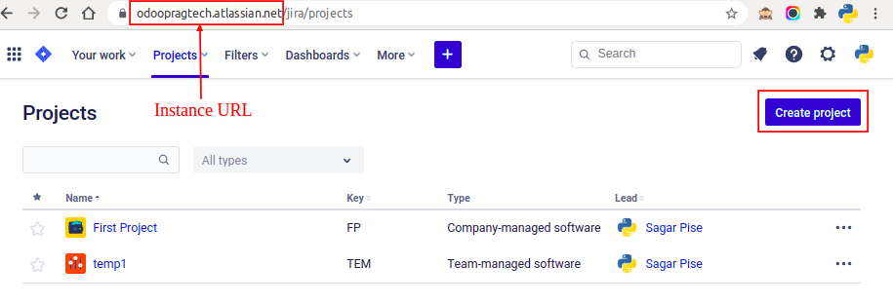

After click on Create Project button you needs to select **kanban** template

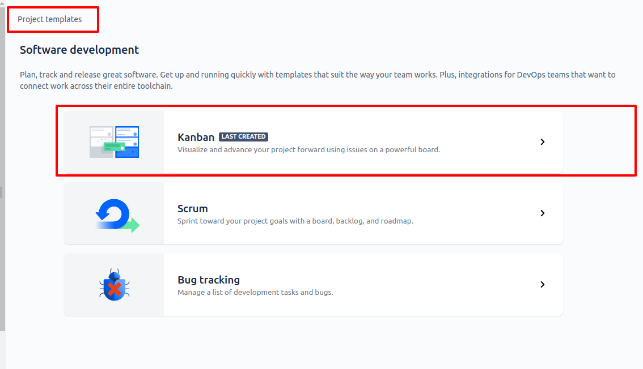

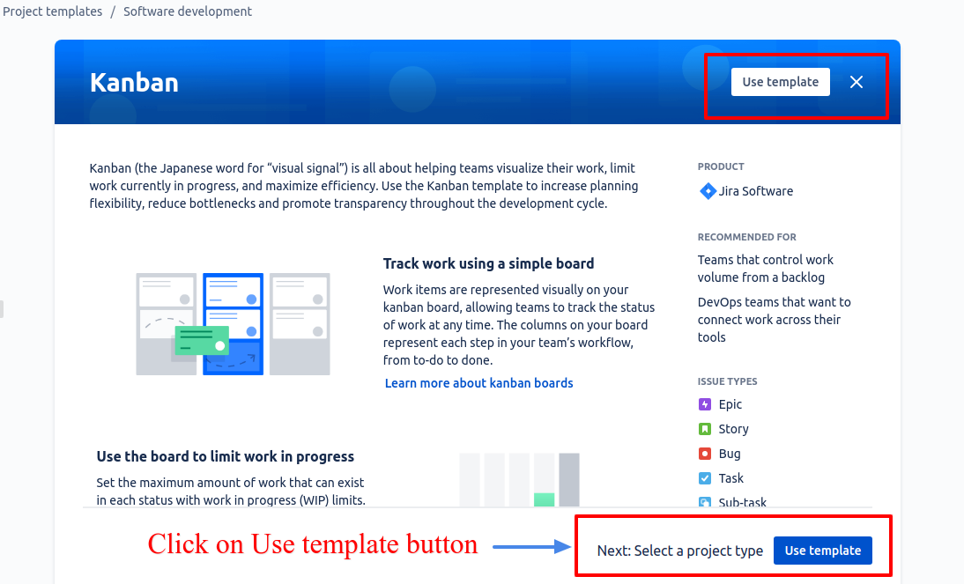

**Step 2** : Enter details for creating projects.

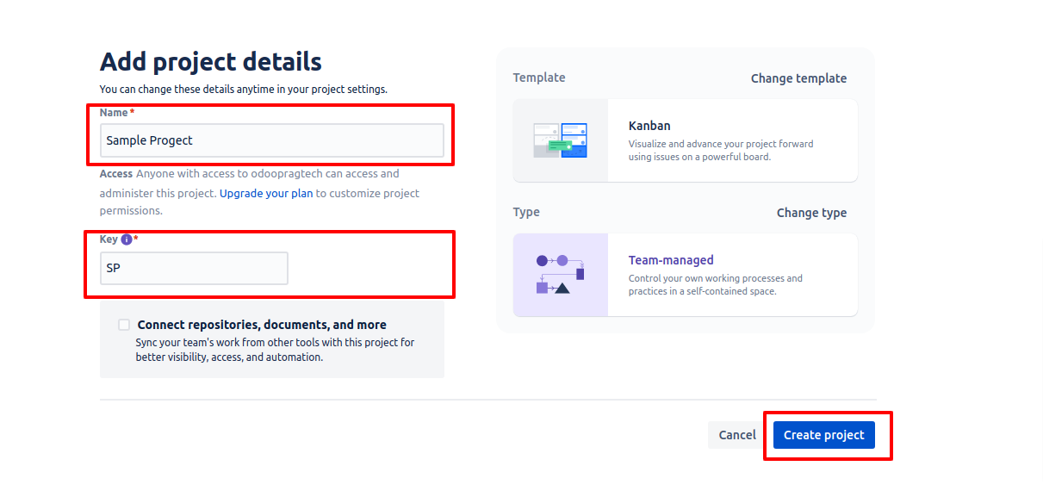

**Odoo Interface :-**

**Step 3 :** Sign In to Odoo Admin Account -> Go to Settings -> Companies Jira Configuration which allows following operations:

For Jira Token Generation follow these steps :

Go to<https://confluence.atlassian.com/cloud/api-tokens-938839638.html> as shown below.

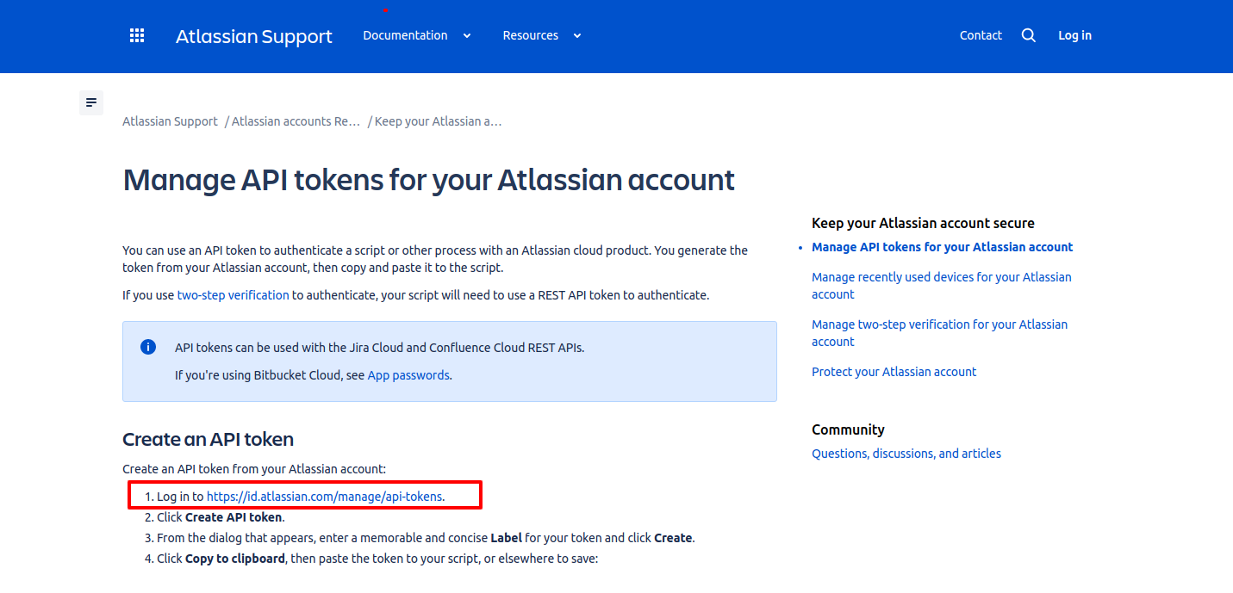

Click on **Create API token**

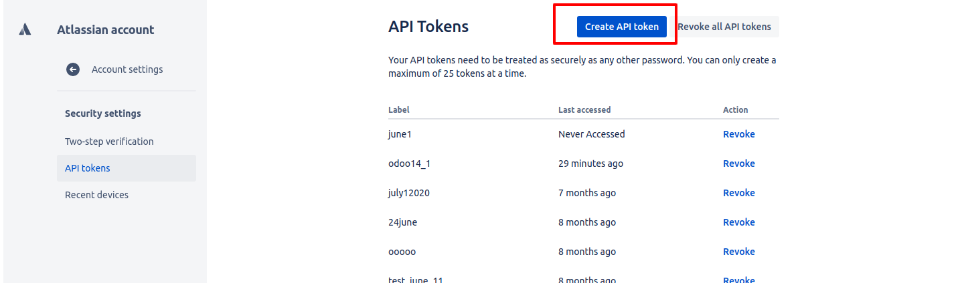

Enter the Instance URL(you can refer to the first screenshot), Jira Login(Email ID), Jira Token as shown below**.**

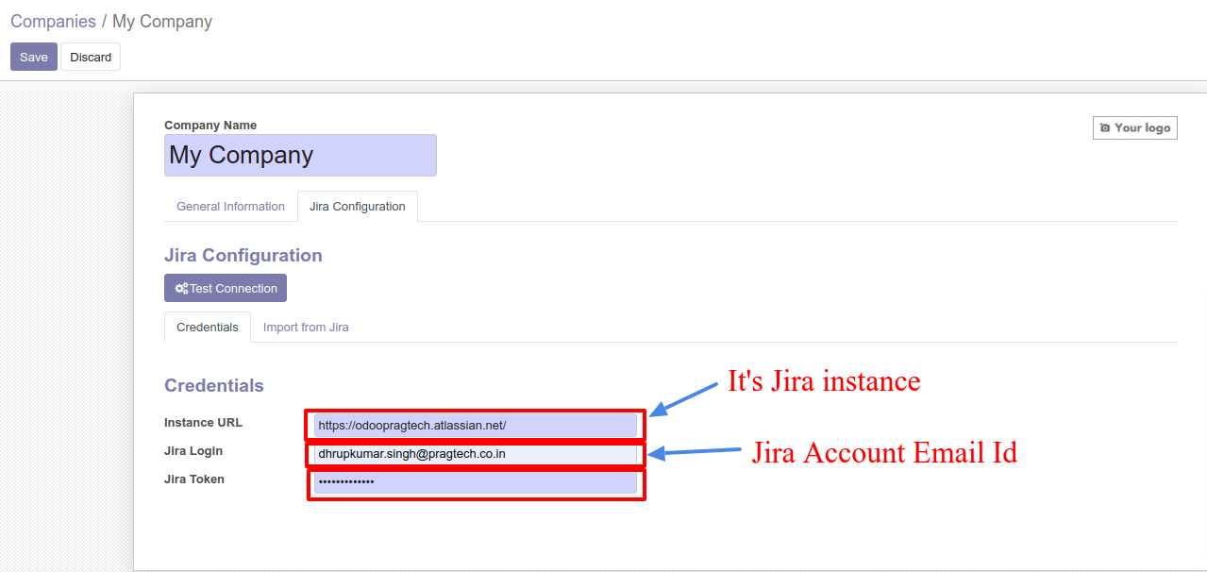

Once all the details are entered, click on “Test Connection”. If Authentication is successful then below message will come

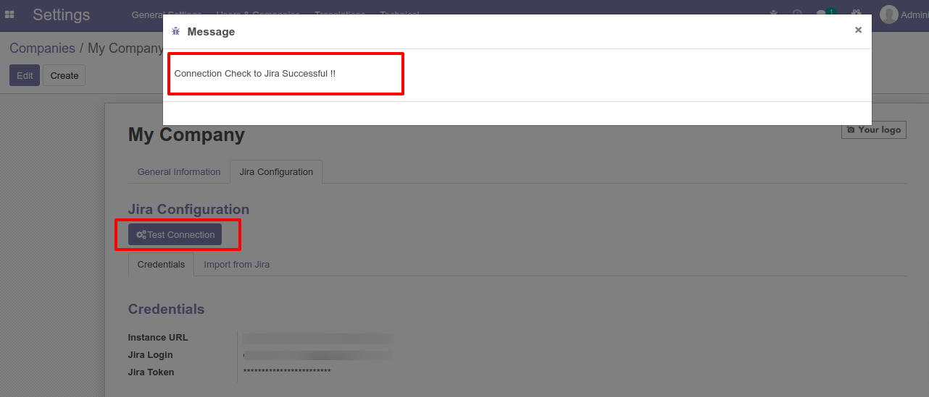

**Step 4**: Import from jira and click on the import project button.

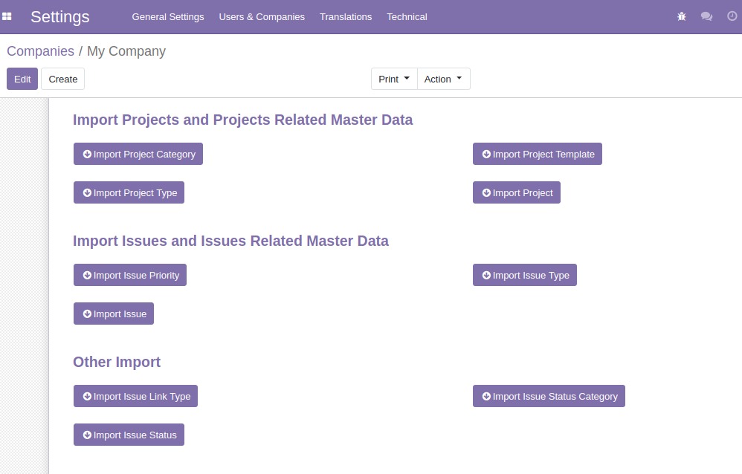

**Step 5** : Users can also import/export the following above mentioned details automatically by using cron as shown below.

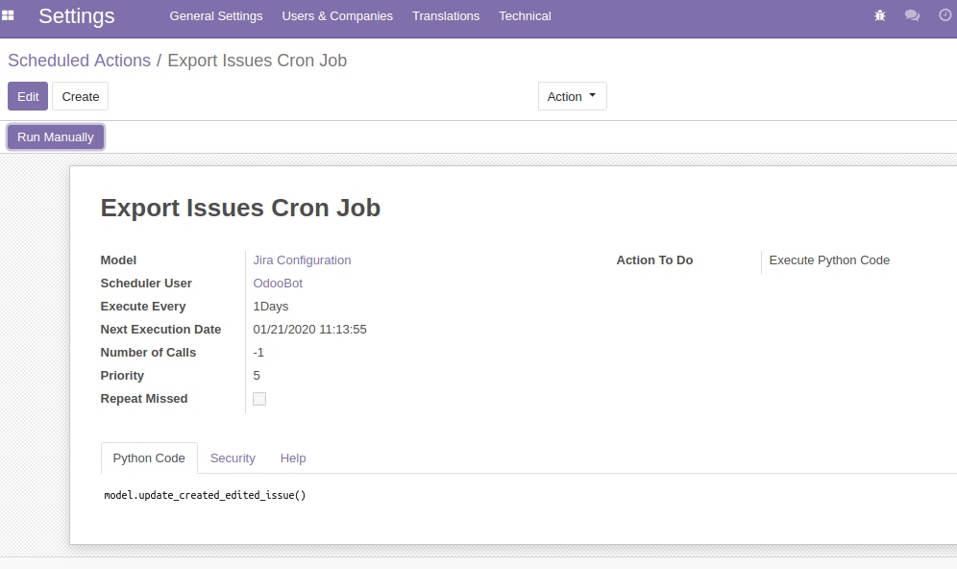



**Step 6** : After importing or exporting the project, the user will be able to see its project transfer respectively.

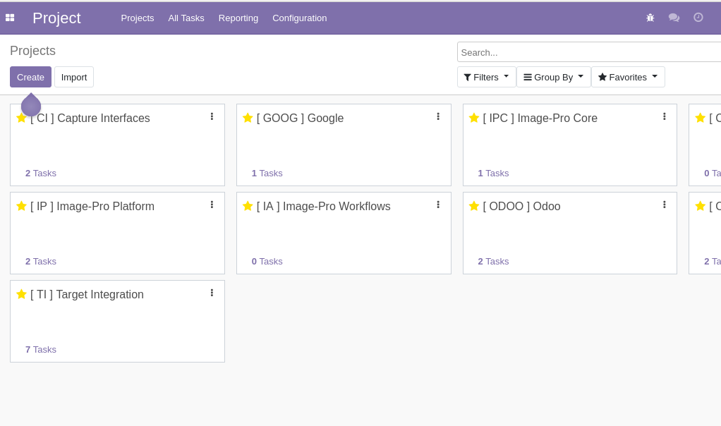

==================== End of Document ==========================